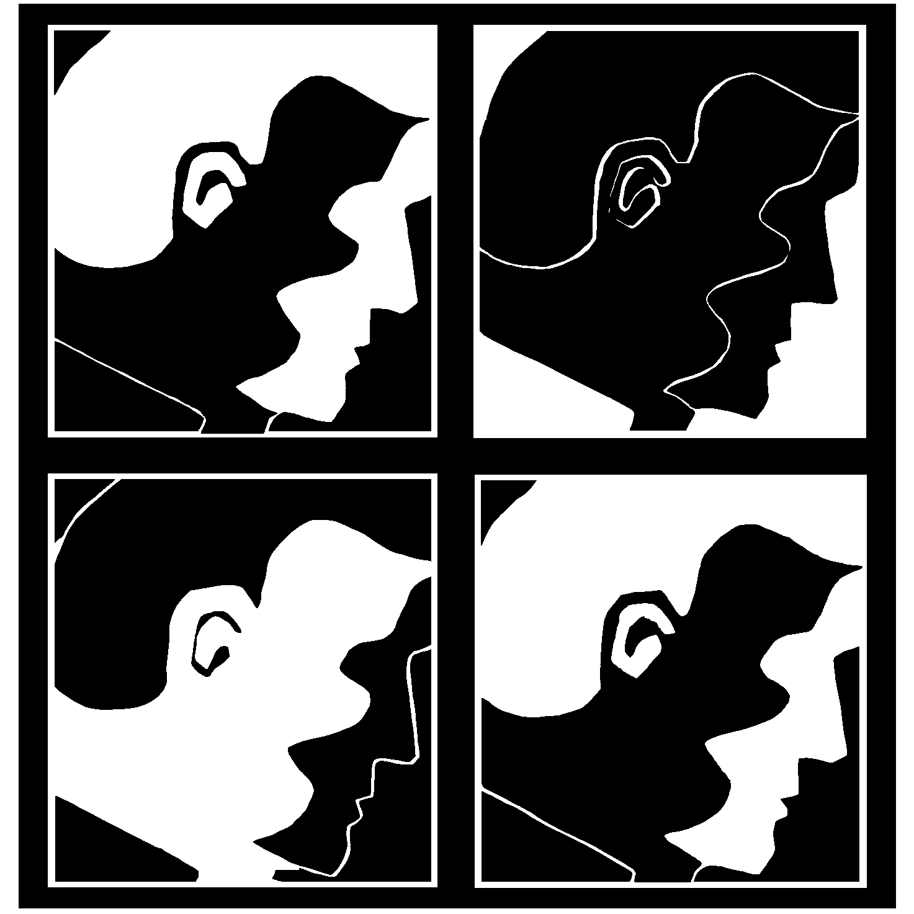
Listening Perspectives Study Center
1439 East Chapman Avenue,
Orange, CA 92866
Phone/Fax (714) 633-3933
www.ListeningPerspectives.com
Identifying and Treating Early Relational Habits
Instructor: Lawrence E. Hedges, Ph.D., Psy.D., ABPP
Tuition for the year (For up to 15 hours of continuing education credit) is $425 to be paid in 3 installments. Early Bird fee of $375 due by September 1, 2020
Section 1 Third Mondays 11:45-1:15 Section 2 Third Tuesdays 10:30-12:00
Section 3 Third Wednesdays 10:30-12:00 Section 4 Third Thursdays 11:00-12:30

NOTE: SINCE SOCIAL DISTANCING IS WITH US FOR THE FORSEEABLE FUTURE ALL CLASSES WILL BE VIRTUAL ON ZOOM AND LIMITED TO 10 PARTICIPANTS
Each participant must enroll for the entire course sequence whether she or he can attend all sessions or not.
Overall Description of the Course Sequence:
This 10 month reading class reviews a massive clinical research project extending nearly 50 years and involving well over 400 psychotherapists participating in clinical case conferences and theoretical discussions at the Newport Psychoanalytic Institute and The Listening Perspectives Study Center in Southern California. The study, led by Lawrence Hedges, has produced 23 peer reviewed books and numerous articles (see website of ListeningPerspectives.com).
Books published in the last five years detail the contributions of previous studies.
The foundations of this course begin with a survey of 100 years of Psychoanalytic research and continue through the formation of Listening Perspectives based on the self and other intersubjective relatedness dimension.
Following are studies in countertransference and listening techniques for dealing with early developmental relational habits or states. Short illustrative vignettes as well as in-depth long-term case studies are presented to guide participants into understanding the theory and technique involved in transference and countertransference analysis with early developmental relational habits or templates.
Schedule and Outline of Each 90-minute Session:
Each participant is asked ahead of time to bring to each session her or his dominant impressions of the salient themes of relational psychotherapy that this month’s text elicited and these are presented to the group with the instructor making comments all along and providing summarizing reflections. Then group members are asked to read aloud one or more passages that struck them as particularly thematic to this relational text and explain how this theme can be applied in the clinical setting. Relational themes and techniques are discussed as well as the emergence of potential therapy transference and countertransference applications in work with clients. The instructor concludes with his overall remarks and questions regarding the dominant as well as the more subtle psychological themes inherent in the study of this particular text and the application of these themes to helping individuals, couples, and families.

Learning Goals: At the conclusion of this course participants will be able to:
- Explain why the Relational Listening approach is fundamentally cross-cultural and can be utilized in any psychotherapeutic orientation.
- State the four relational listening perspectives and the relatedness dimension which each seeks to define.
- Define “role-reversal“ countertransference in the characterological personality organizations.
- List four kinds of countertransference experience to the organizing (psychotic) experience.
- State three important features of the transference psychosis in the Sandy case.
- State which developmental habits the “organizing experience” entails.
- Explain what a “symbiotic scenario” involves.
- State four reasons why it is difficult to “make love last”.
- Explain why it is important to understand “the clamor” in analyzing “organizing” level transference.
- States three reasons why you feel the Relational Listening approach is valuable or not.
- Explain the concept of “energy arc” and why it is a helpful metaphor.
- List 3 important aspects to the regressive experience in “Terrified by the Disconnecting Rage” case study.
- State why it is important to relinquish PTSD in favor of PTSE.
- Name 4 different important perspectives in considering Sex in Psychotherapy.
- Explain why Davidson in the Ronnie case was careful not to damage the pigeon cage.

Learning Goals:
Therapists in community practice have a variety of different training backgrounds as well as very different personal and professional experiences and lives. By coming together to share their experiences around the collective emerging themes of Relational approach within various schools of psychotherapy they enrich their collective understandings of the subjective psychological and emotional concerns, issues, and themes of their clients. This increased awareness and sensitivity allows a broader understanding of the emotional and psychological issues arising in their relational work with individuals, couples, and families. Further, group sharing allows an honest appraisal of how these issues are expressed in the emotional transferences toward therapists as well as the countertransferences toward clients.
Texts: over the 10 months approximately 100 pages of reading will be required each month. The readings involve excerpts from 12 of the published books in this research project. The monthly readings have been collected and are available electronically as: Hedges: A Retrospective. They are in a word format.

Hedges, L. (2000).Terrifying Transferences: Aftershocks of Childhood Trauma. New Jersey: Jason Aronson Publishers.
_____(2013) Relational Interventions: Treating Borderline, Bipolar, Schizophrenic, Psychotic, and Characterological Personality Organization. International Psychotherapy Institute e-Book, freepsychotherapybooks.org.
_____2015) Sex in Psychotherapy. New York: Routledge.]\
____(2017). Facing the Challenge of Liability: Practicing Defensively. Lanham, MD: Rowman Littlefield Publishers.
_____(2018). Relational Listening: A Handbook. International Psychotherapy Institute e-Book, freepsychotherapybooks.org.
_____(2018). The Call of Darkness: a Relational Listening Approach to Suicide Intervention. International Psychotherapy Institute e-Book, freepsychotherapybooks.org.
_____(2020). Terror in Psychotherapy: The New Zealand Lectures. International Psychotherapy Institute e-Book, freepsychotherapybooks.org

For registration and information call (714) 633-3933 or go to www.listeningperspectives.com
October 2020 Session 1, VOL I  Relational Listening: a Handbook—109 pages  Also available on freepsychotherapybooks.org free download or paperback $19 from Amazon.  Main topic: Relational approaches require a different epistemology involving constructing listening perspectives of various levels of relatedness possibility during the early years of life and how these emerge in client’s ongoing concerns,  November 2020, Session 2, VOL I  Selections form Listening Perspectives in Psychotherapy: pp ix-25,43-46, 66-69,135-140, 260-260. and from Interpreting the Countertransference: pp ix-48, 385-411.  Main Topic: Listening in the broadest sense possible includes several kinds of countertransference sensitivity that can be used to study and work with client’s relational experiences in life.  December 2020, Session 3, VOL II  Selections from Strategic Emotional Involvement : ppxii-7,127-139,157-196, 285-312.  Main Topic: Case studies illustrate the workings of transference and countertransference experience with clients.  January 2021, Session 4, VOL II  Selections from In Search of the Lost Mother of Childhood, pp xi-35 and 283-338, Case: Playing Peek-a-boo with Sunglasses, pages 75-110.  Main Topics: An overview of “the organizing experience” and an in-depth case study illustrate how therapists can effectively work with the earliest levels of relational experience of their clients.  February 2021, Session 5, VOL II  Selections from Working the Organizing Experience, pp xv to 22, 131-143, 209-259, 269-277 and Selections from Remembering, Repeating, and Working Through Childhood Trauma: pp xi-269 | March 2021, Session 6, VOL III  Selections from Terrifying Transferences, pp xi-42 and 315-377, case: Terrified by Disconnecting Rage, pages 233-270  April 2021, Session 7, VOL III  Facing Our Cumulative Traumas—122 pages  Also available on freepsychotherapybooks.org free download or paperback $19 from Amazon, and Selections from Sex in Psychotherapy, ppxiii-44 and 133-170. Main Topics: How relational traumas are universal and occur to all people throughout a lifetime and the main perspectives that are helpful in working with client’s sexual concerns.  May 2012, Session 8, VOL IV  Relational Interventions Part 1: Parts I and II, pages 1-99  Also available on freepsychotherapybooks.org free download or paperback $19 from Amazon  Main Topic: How to formulate and work with clients’ earliest relational habits as they appear in life and in the psychotherapy relationship.  June 2012, Session 9, VOL IV  Relational Interventions Part 2: Parts III and IV, pages 99-162  Also available on freepsychotherapybooks.org free download or paperback $19 from Amazon.  Main Topic: How to formulate and work with clients’ emotional and relational habits that first emerged during the symbiotic level of relational development.  July 2012, Session 10, VOL IV  Making Love Last-109 pages  Also available on freepsychotherapybooks.org free download or paperback $19 from Amazon.  Main Topics: How difficult it is for couples to devise ways of making love last and how therapists can be most helpful.
For more information and registration call (714) 633-3933
Continuing Education Certificates and Credits
This course meets the qualifications for 15 hours of continuing education credit for LMFTs, LCSWs, LPCCs, and/or LEPs as required by the California Board of Behavioral Sciences. The Listening Perspectives Study Center is approved by the California Association of Marriage and Family Therapists to sponsor continuing education for LMFTs, LCSWs, LPCCs, and LEPs. The Listening Perspectives Study Center maintains responsibility for this program/course and its content.
CAMFT Approved Provider# 25946

About The Listening Perspectives Study Center
The Listening Perspectives Study Center is an equal opportunity CE provider committed to principles equality and of social justice. Information regarding registration, fees, refunds, attendance policies, credits, instructors qualifications, ethics, grievances, and conflicts of interest are spelled out on our website, Listeningperspectives.com
There are no commercial interests or conflicts of interest involved in this Continuing Education class. Full attendance and completed course evaluation are required for Continuing Education credit for class. The knowledge and usefulness of the material presented in this class is based upon research and is limited to the contexts discussed. No experimental or dangerous procedures are part of this class.
The Listening Perspectives Study Center is committed to ensuring that our programs are accessible to participants with disabilities. Contact the center with your request and every effort will be made to accommodate you.
Unless otherwise specified Tuition is $95.00, Payments can be arranged and some scholarships are available. Full refunds are made if the course is cancelled by fax or letter 10 days before the first meeting

